Kinetic energy 动能shock absorbers 减震器Side force and roadholding 侧向力和抓地力Asphalt 沥青Sunroof 天窗a hard-packed gravel road 坚硬的碎石路repression 抑制，压迫arterial动脉intoxicatel 酒酣hare野兔conceal隐藏fuses 保险丝counterclockwise逆时针prone易于collided撞上moisture水分湿气facilitate促进backrest靠背respiratory arrest呼吸骤停fracture骨折hazard风险tandem axle串联轴infrasound次声towbars牵引whiplash鞭打frost霜 glycol乙二醇ethanol乙醇refrain避免 ozone臭氧kerb（curb）马路牙子slammed猛烈撞击

The need for side force increases and decreases **quadratically** in relation to speed.

Grip(抓地力) is reduced by **rain**, **snow** and **ice**, pollution such as **oil** and unevenness such as **gravel**. Grip is also affected by the **quality and condition of the tyres**.

If the car's speed changes, the kinetic energy changes **quadratically** (平方)

braking distance is directly proportional(正比) to kinetic energy.

Understeer can be caused when:

* The front tyres are aquaplaning.
* The driver in a car without ABS (anti-lock braking system) brakes so that the front wheels lock.
* The driver engine brakes or accelerates too hard in a front-wheel drive car.
* The car is too heavily loaded at the front.
* The front tyres are worn or have insufficient air pressure.
* A trailer or caravan is connected.
* The differential is locked

Oversteer is most common in rear-wheel drive cars and is particularly noticeable when accelerating in curves, but can also be caused when:

* The rear tyres are aquaplaning.
* The driver is braking hard.
* The driver engine brakes or accelerates too hard in a rear-wheel drive car.
* The car is too heavily loaded at the rear.
* The rear tyres are worn or have insufficient air pressure.
* A trailer or caravan is connected.
* There are strong side winds.

An uneven road surface can also cause a car to oversteer.

Electronic stability control systems(ESC) can prevent the car from skidding by braking individual wheels, or throttling the engine

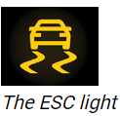

the best tyres should always sit on **the rear axle.**

Tyres **older than 10 years** should be replaced

New summer tyres have a tread depth of 7-8 millimetres.

New winter tyres have a tread depth of 9-10 millimetres. To get the best grip, you should replace winter tyres when the tread depth has been worn down to 4-5 millimetres.

You should check tyre pressures at least **once a month**.

pressures should be measured when the **tyres are cold**

The wrong air pressure can increase fuel consumption, shorten tyre life, lengthen the braking distance and impair the car's driving characteristics.

If the air pressure is too low in one of the front tyres the car may start to **pull diagonally**. If there is too little air in both front tyres (or if they are worn), the car may start to **understeer** more than usual. If there is too little air in both rear tyres (or if they are worn) the car can start to **oversteer** more than usual.

After a change of wheels it is important to retighten the wheel nuts when you have driven about 50-100 kilometres. Otherwise you risk a wheel nut or an entire wheel coming loose during travel.

This is especially important to remember if your wheel rims are **alloy**(light metal). Note that such rims should be tightened with a special torque wrench to avoid damaging them.

Wheel alignment means that the wheels' angles are adjusted so that they are perpendicular to the ground and parallel to each other. Wheel balancing means that the wheels are adjusted so that they can rotate without vibrating at certain speeds.

**Incorrect wheel alignment**

* The car **pulls diagonally** when driving on a straight road.
* The **outer edges** of the front tyres wear faster.

**Incorrect wheel balance**

* **The steering wheel shakes** at a certain speed.
* Unevenly worn patches on the tyres.

Emergency wheels are designed for short distances, usually **80 kilometres or less**, and relatively low speeds, usually **80 km/h at most**. Emergency wheels should have higher air pressure than regular tyres.

Worn shock absorbers result in **impaired grip** – especially in curves and when braking – and **braking performance**. If the rear shock absorbers are in poorer condition than the front, **the risk of rear wheel skid increases**.

 Modern cars are usually front-wheel drive because it is considered to provide better driving characteristics than rear-wheel drive on slippery roads.  Advantages of rear-wheel drive cars are that they are usually easier and cheaper to maintain and that they are better suited for heavy trailers.

A four-wheel drive car consumes about**5-10% more fuel** than a front or rear-wheel drive car of equivalent size and model.

If you experience "steering wheel jerks" while driving, and if steering alternates between easy and sluggish, **dirt or air** has probably entered the power steering system.

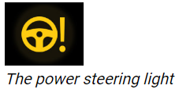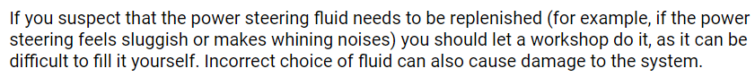

hydraulic dual circuit brake system液压双回路制动系统

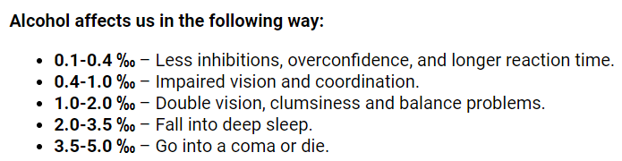 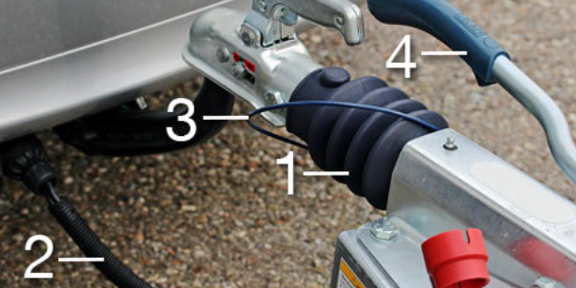 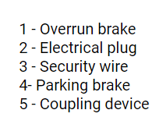 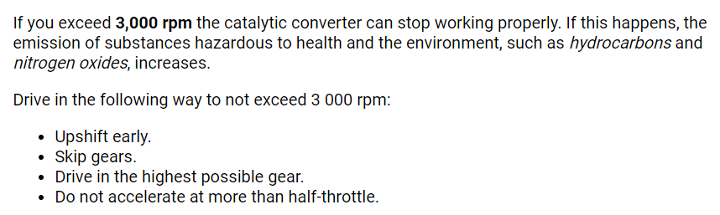 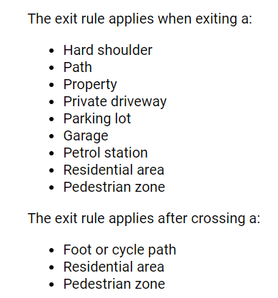 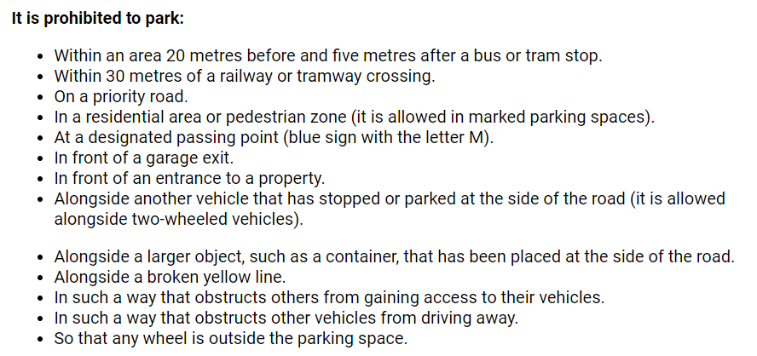 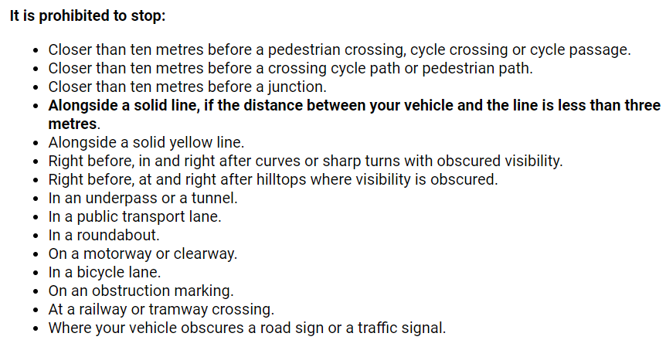 

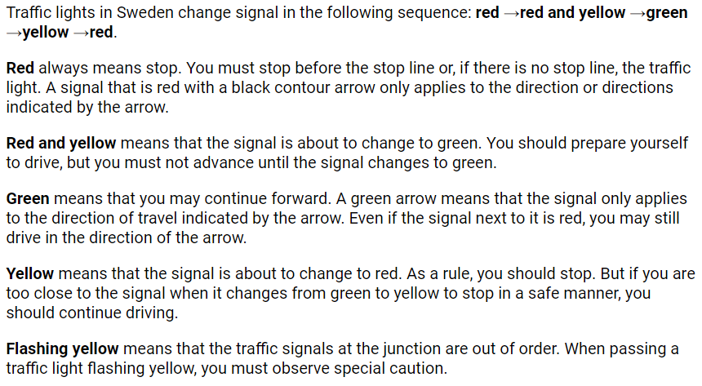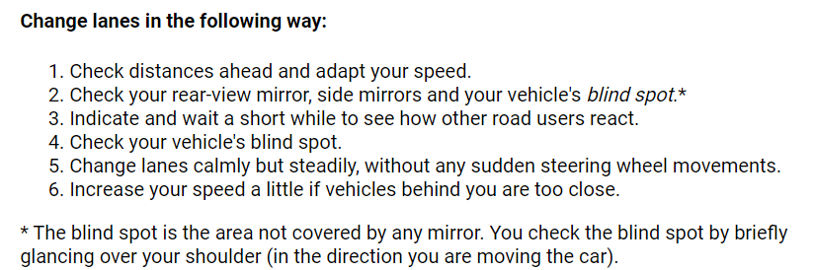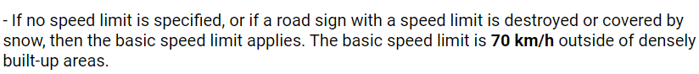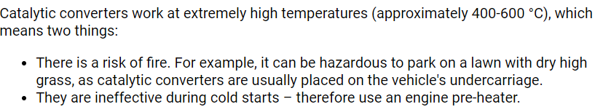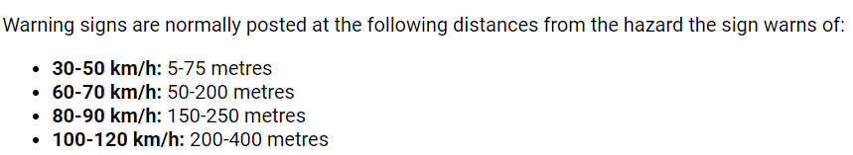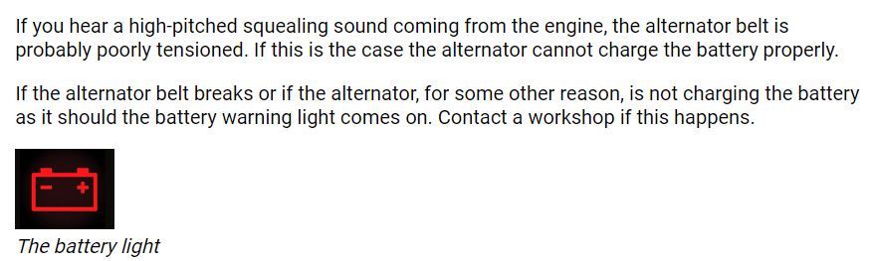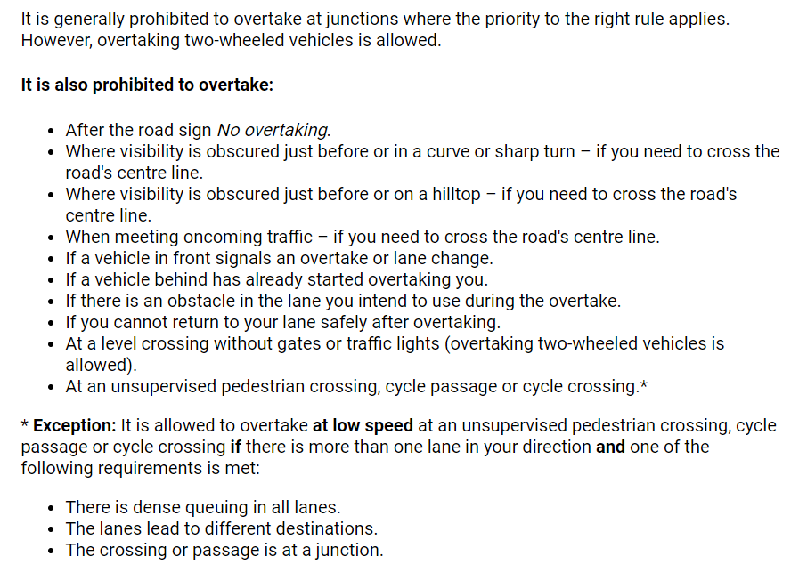

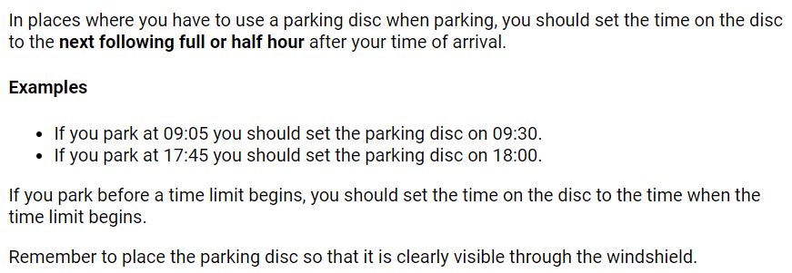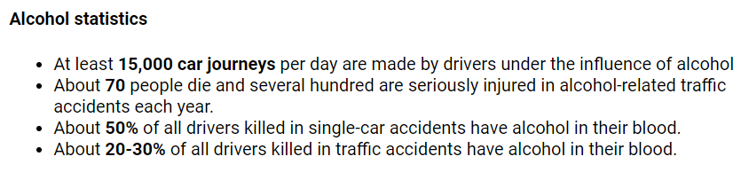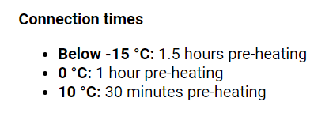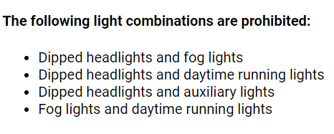

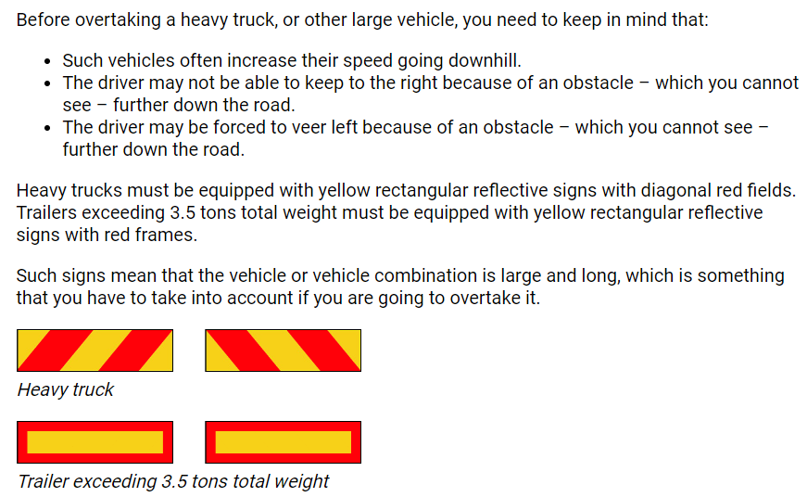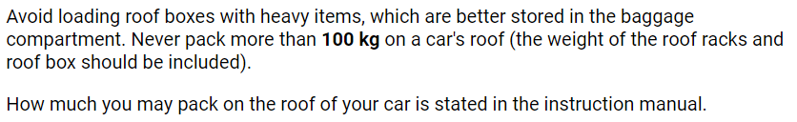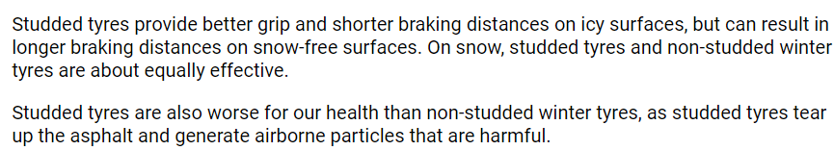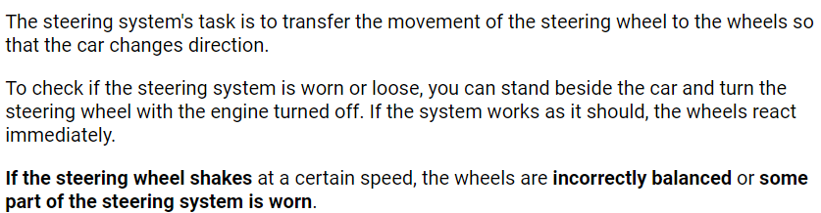

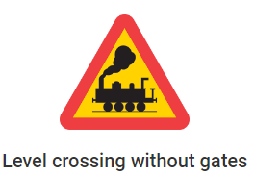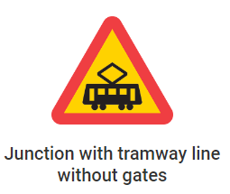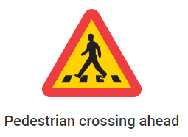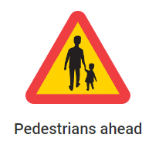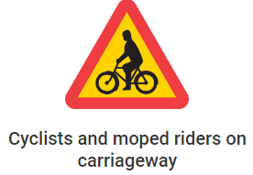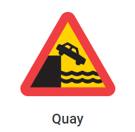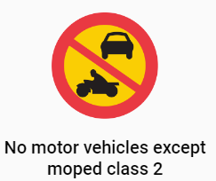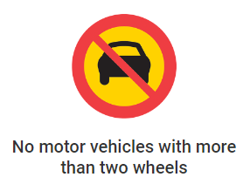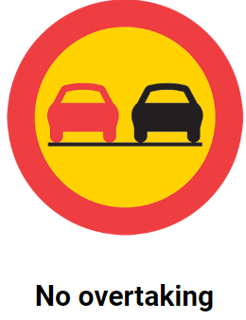

The road sign prohibits overtaking motor vehicles with more than two wheels. You may still overtake two-wheeled mopeds and motorcycles, but not tricycles, quad bikes or motorcycles with sidecars.

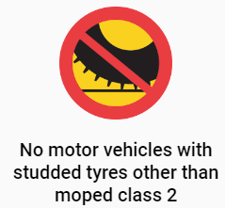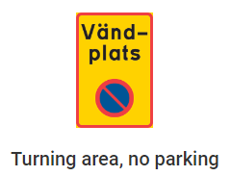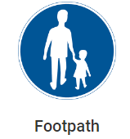

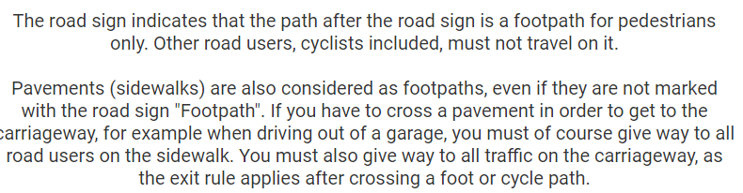

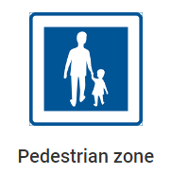

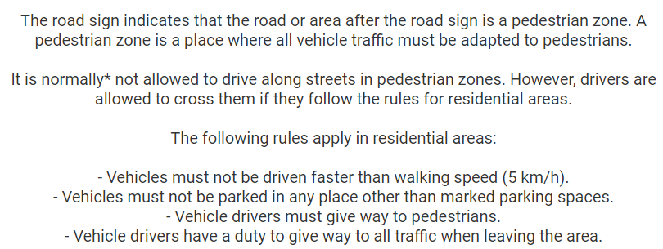

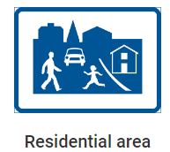

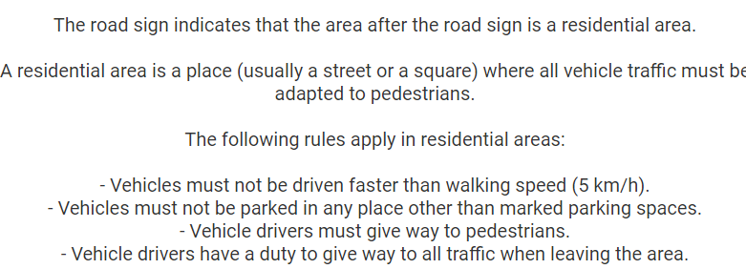

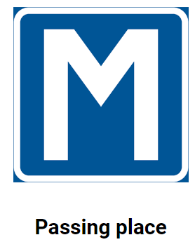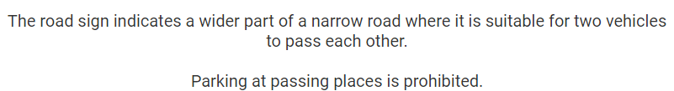

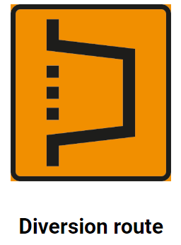

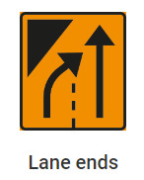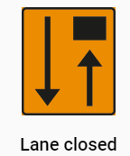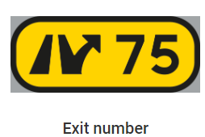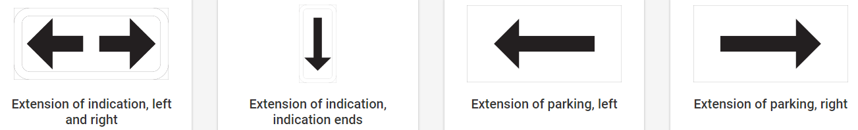

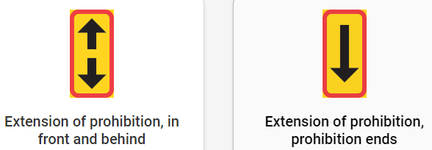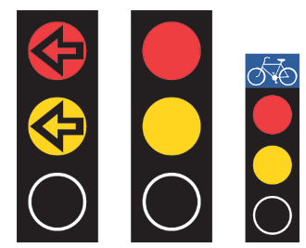

Red and yellow means that the signal is about to change to green.

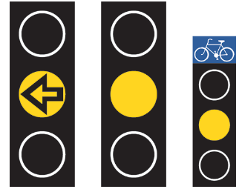

Yellow means that the signal is about to change to red. 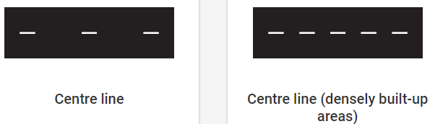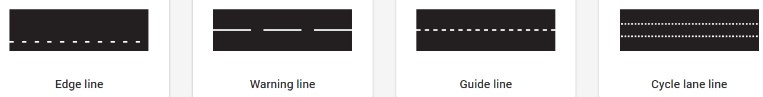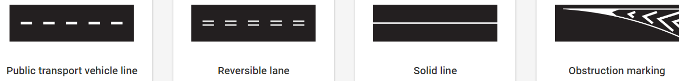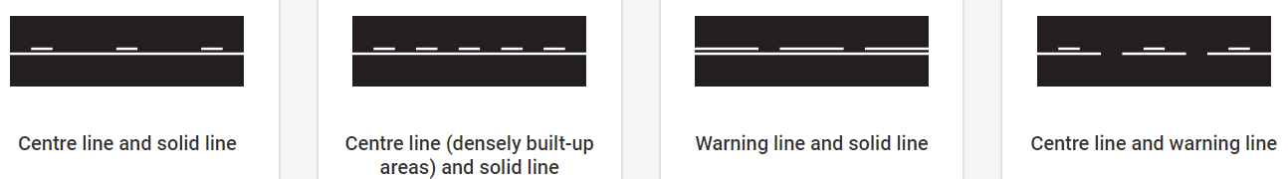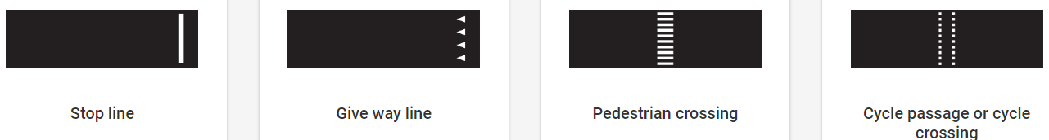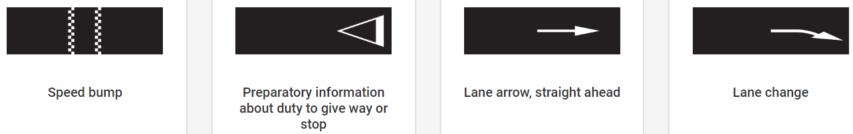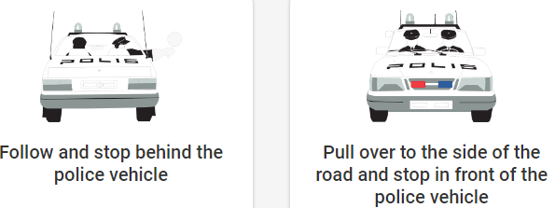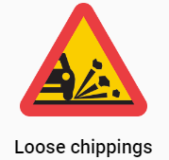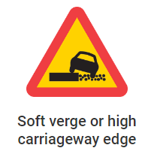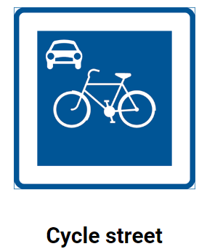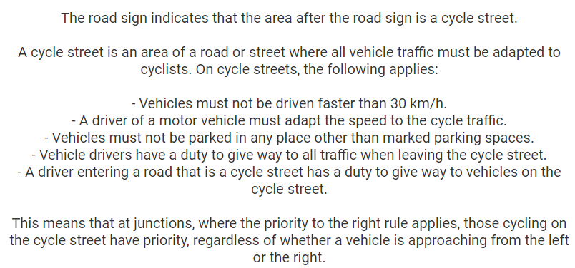

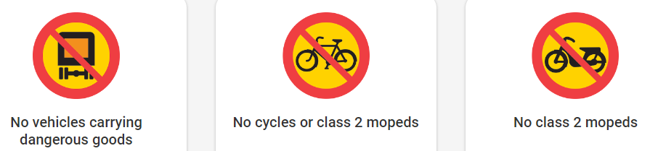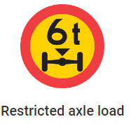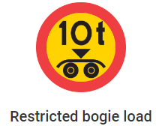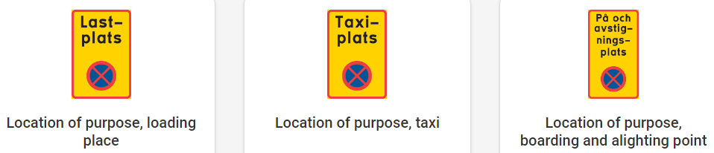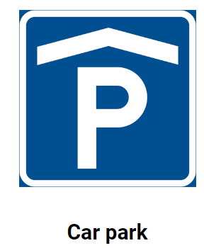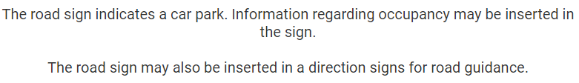



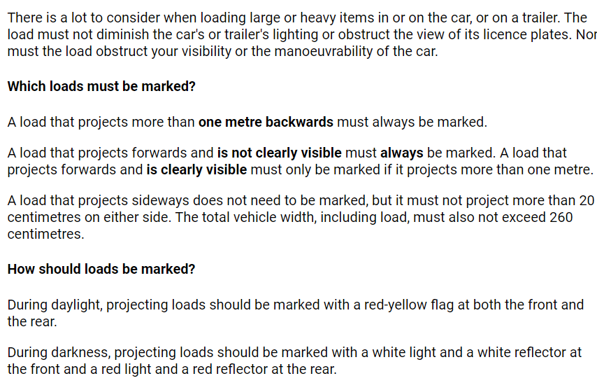

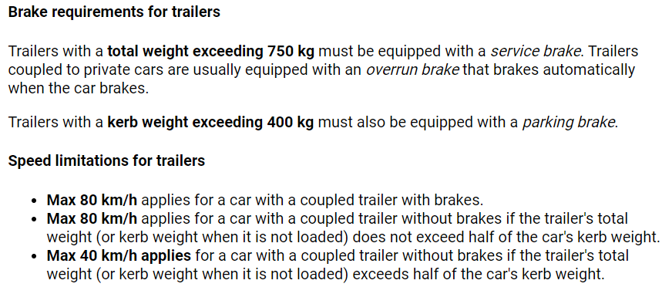

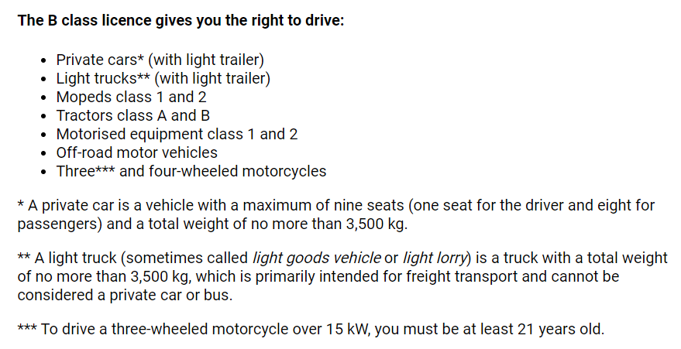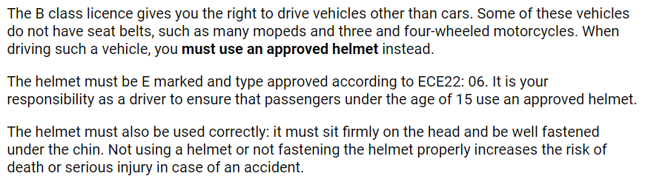

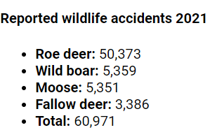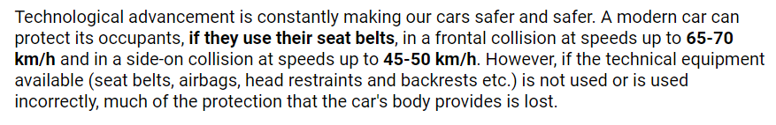

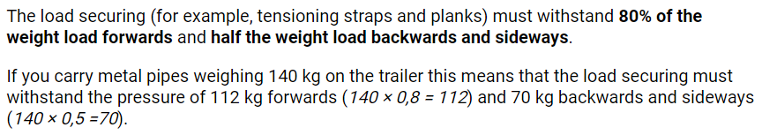

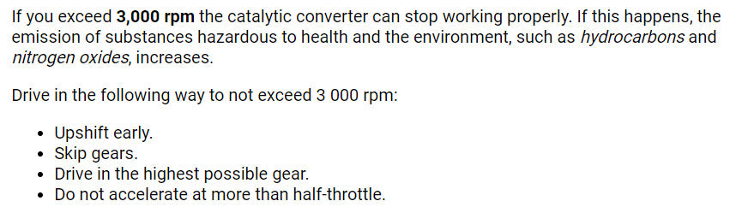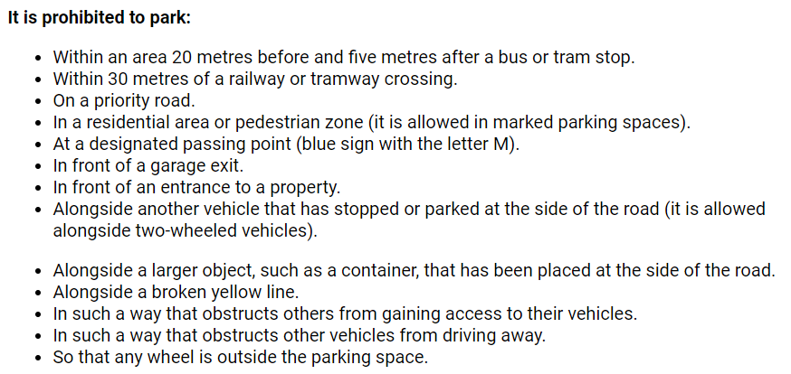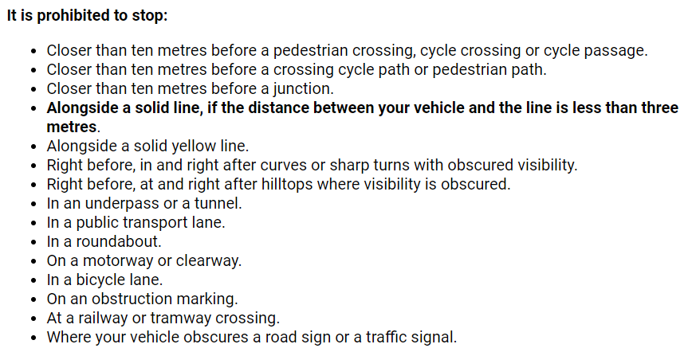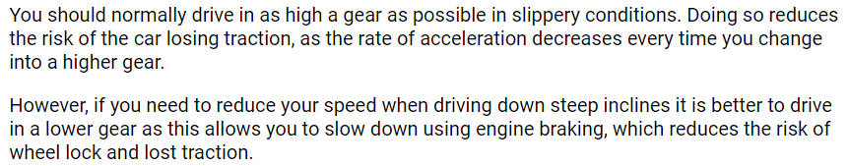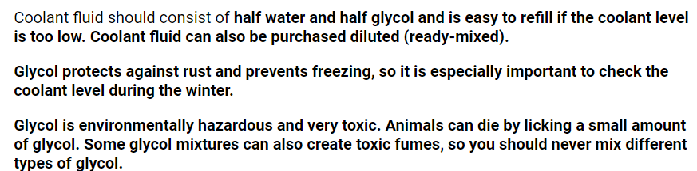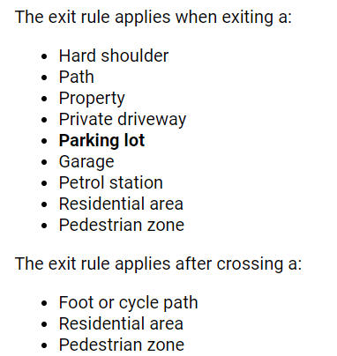

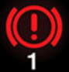

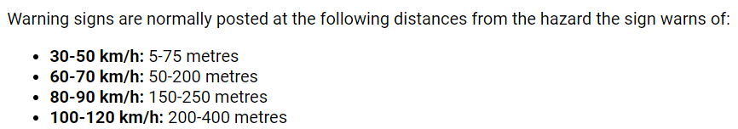

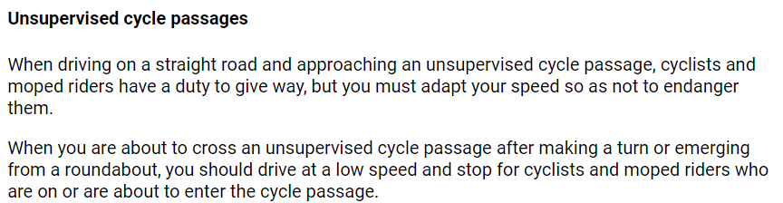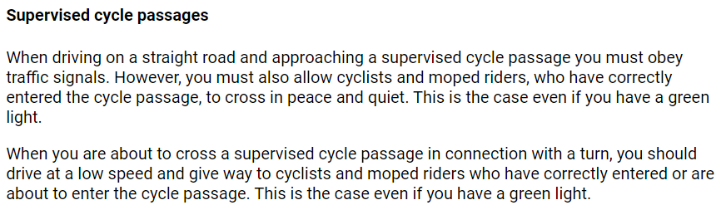

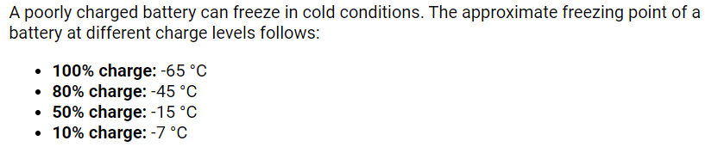

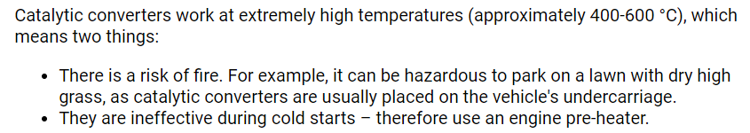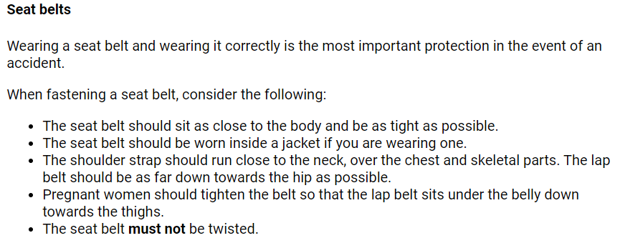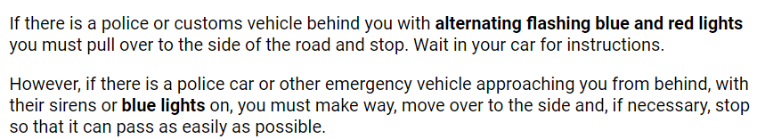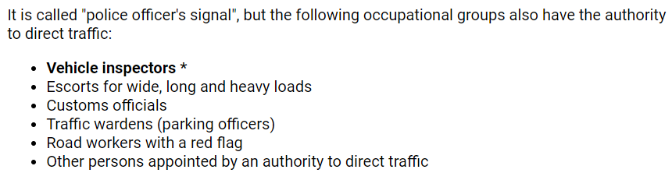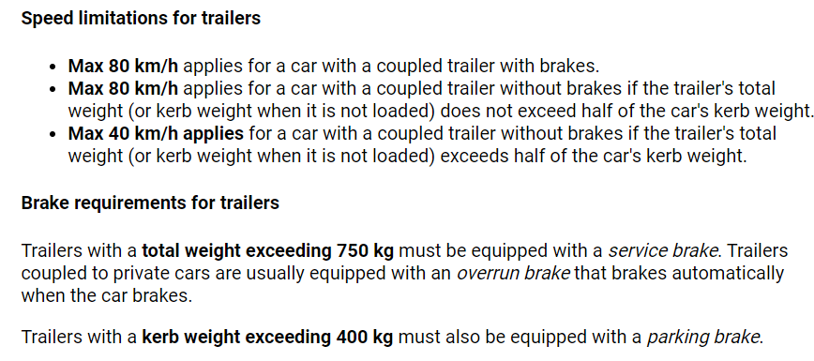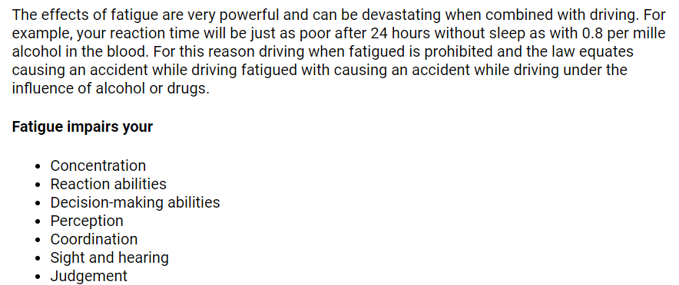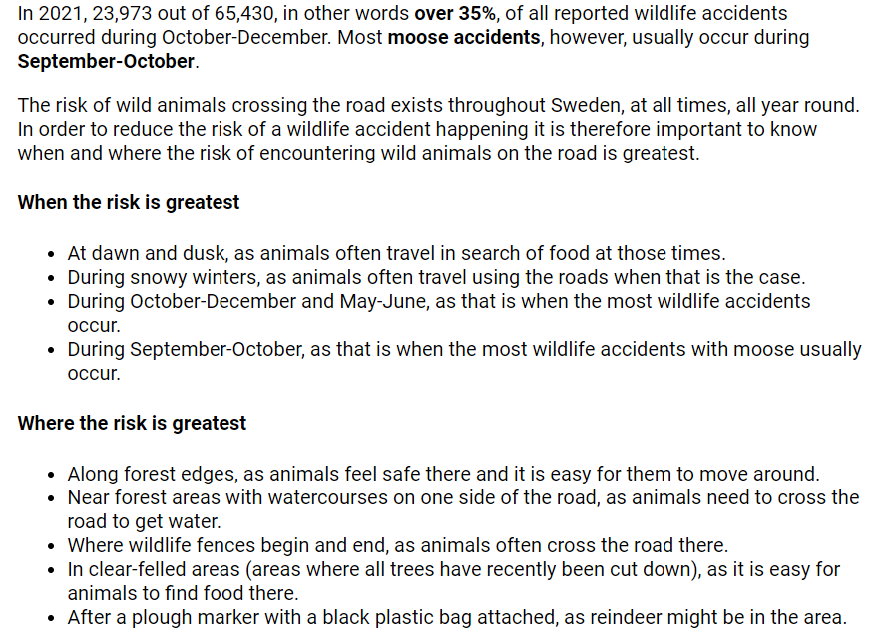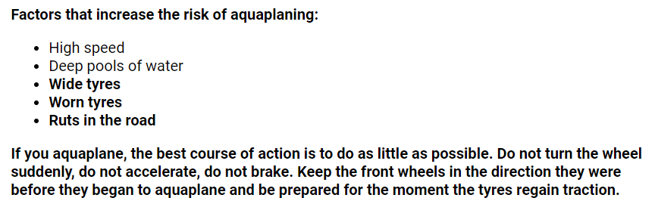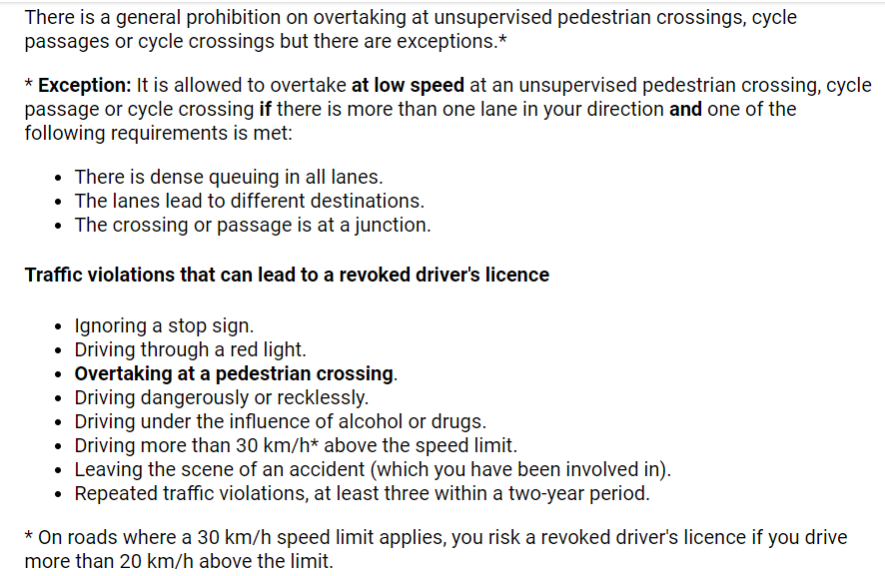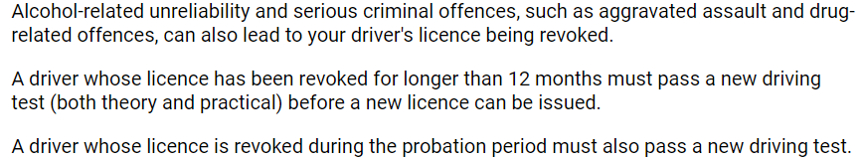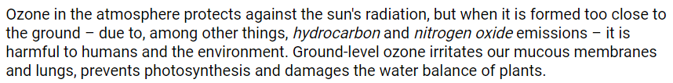

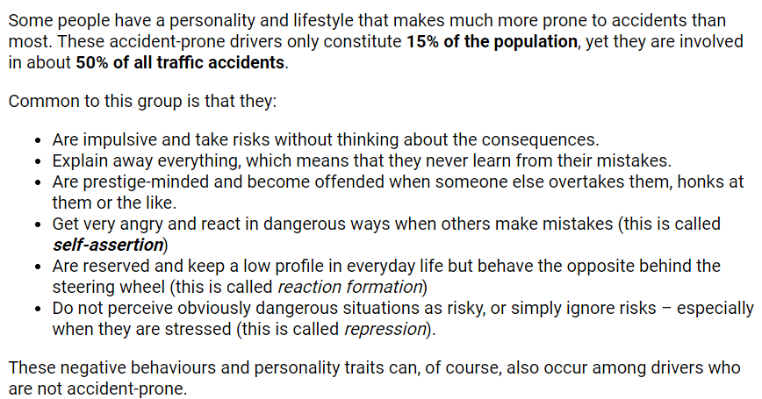

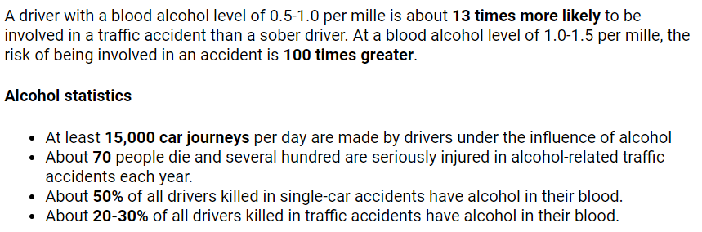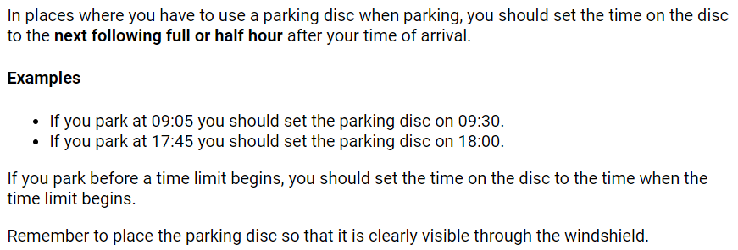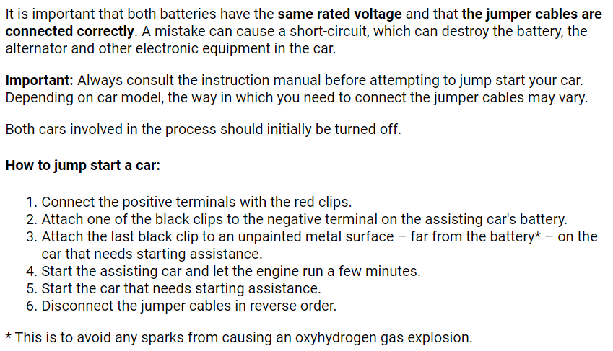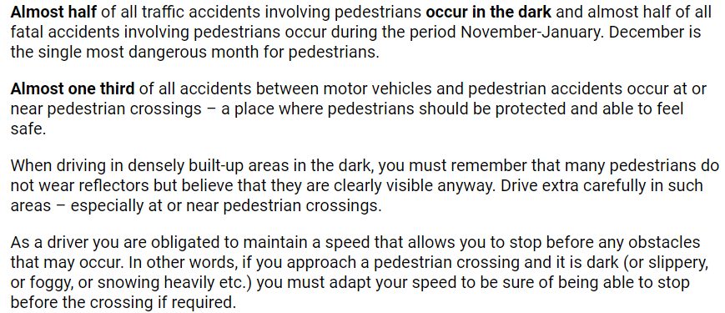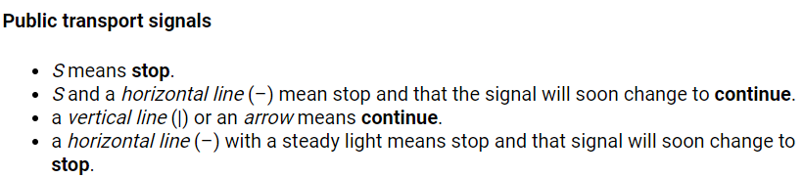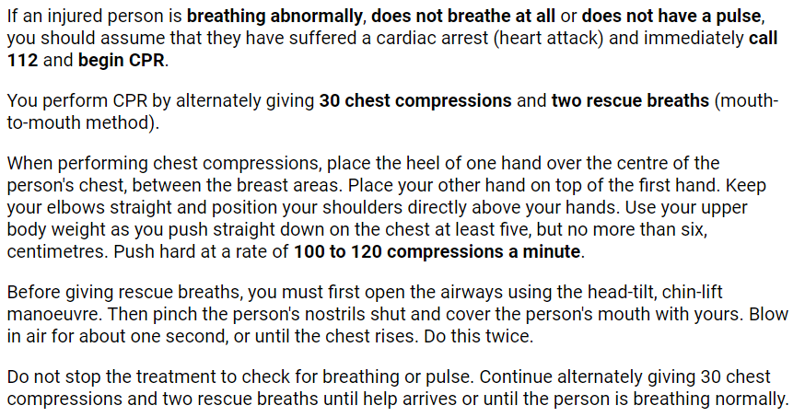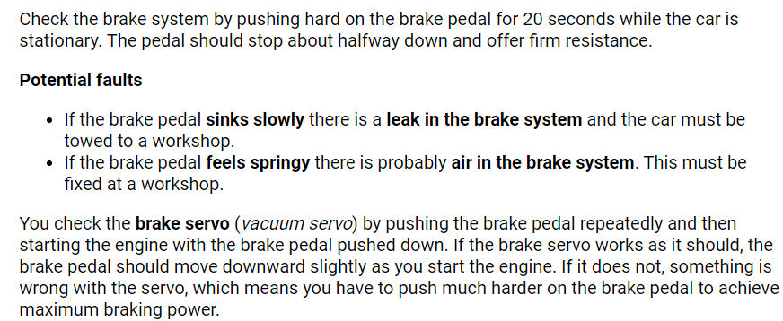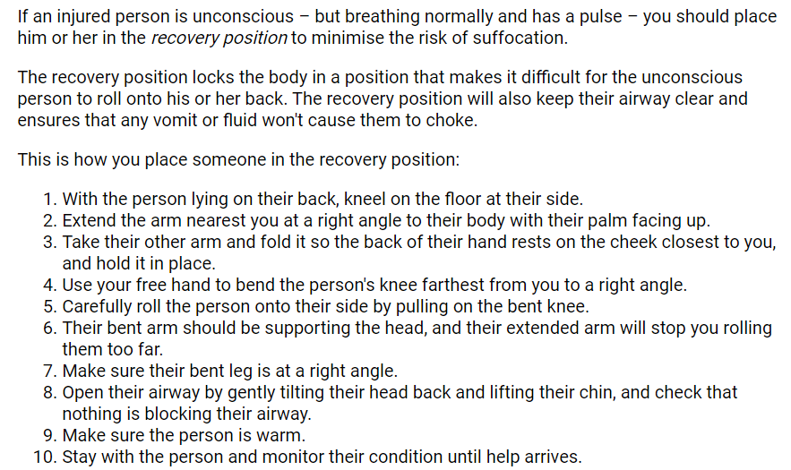

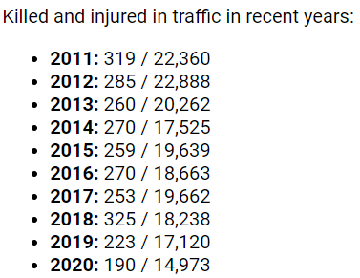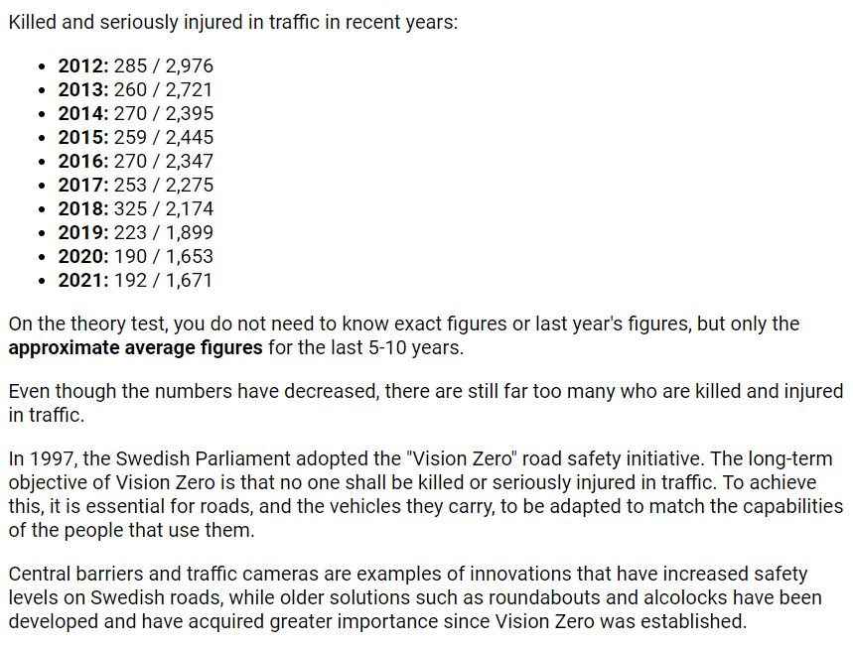

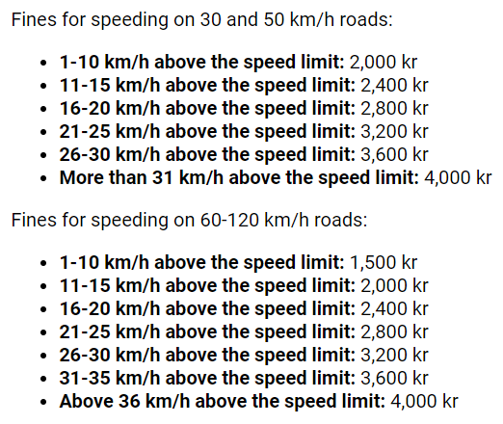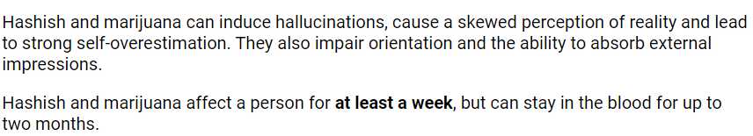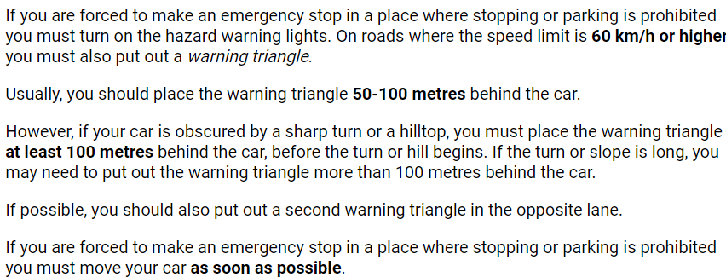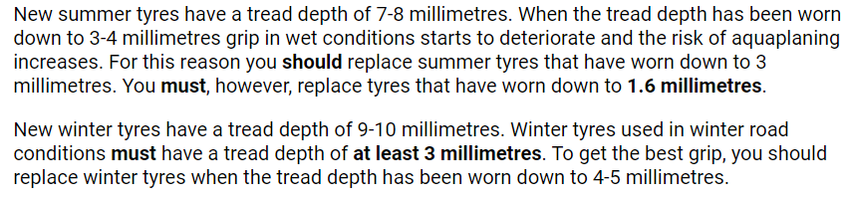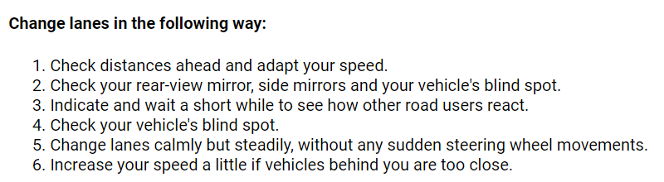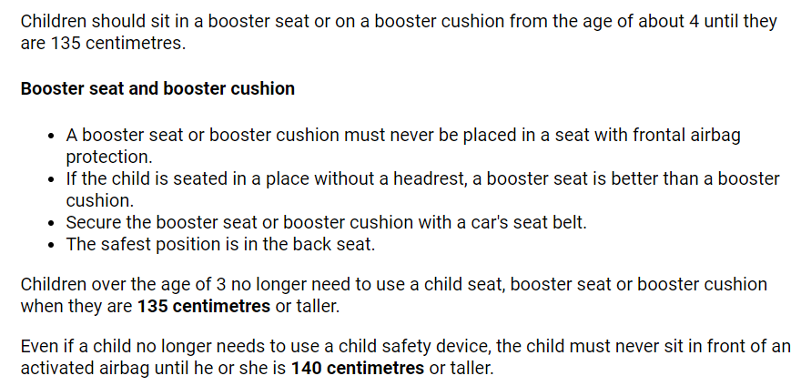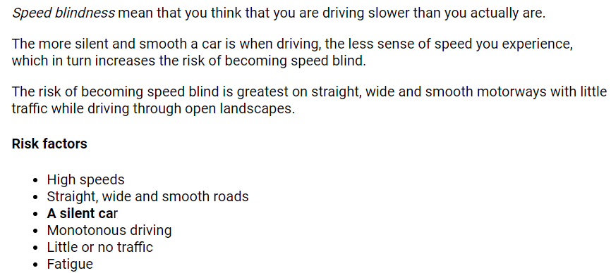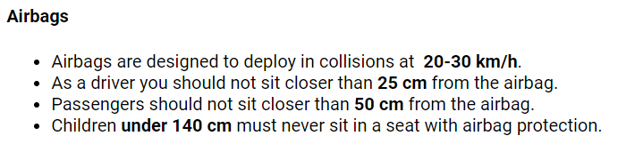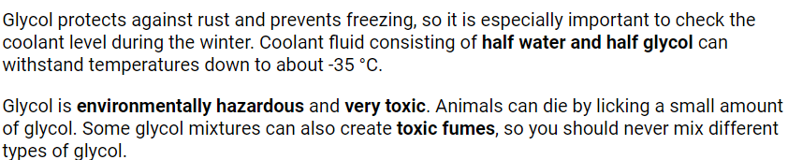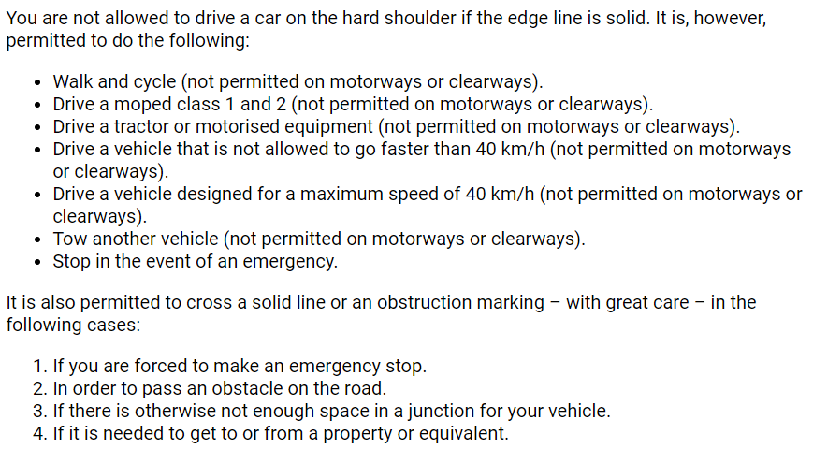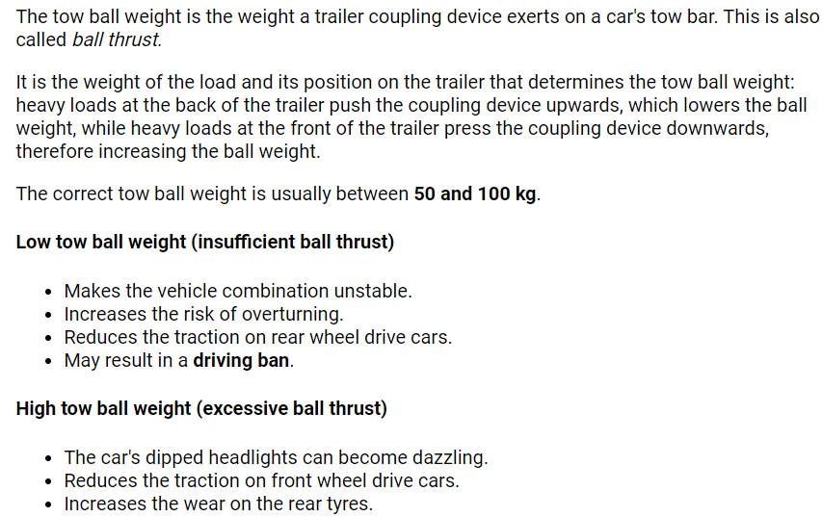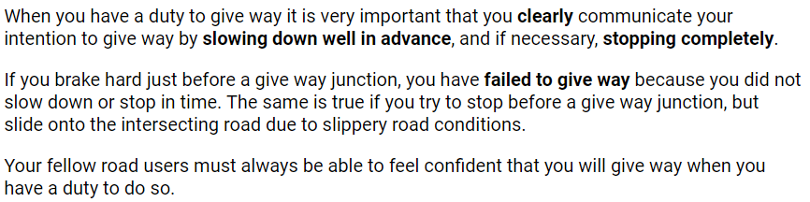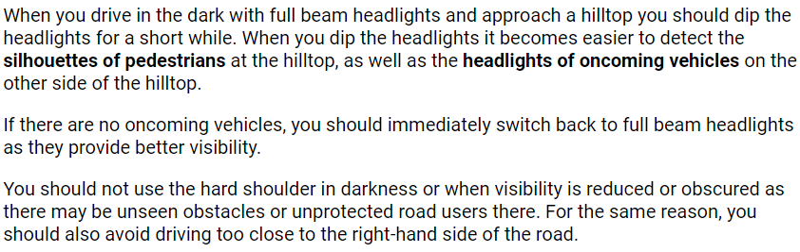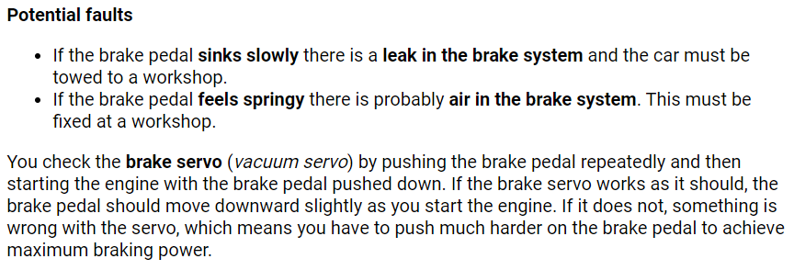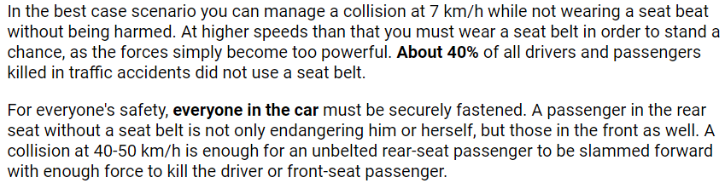

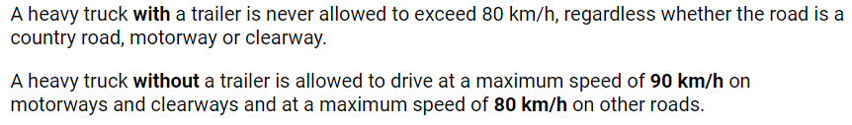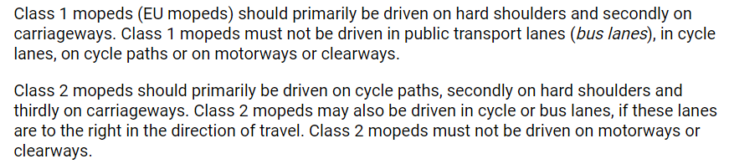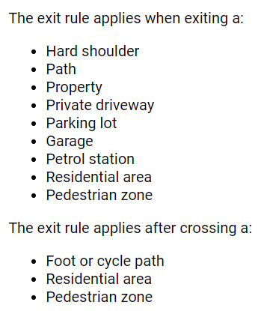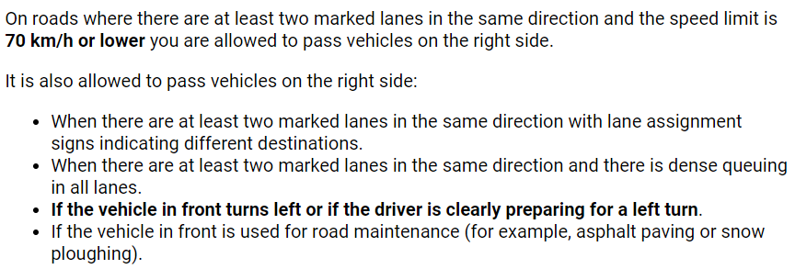

Idling allowed no more than 1 min

